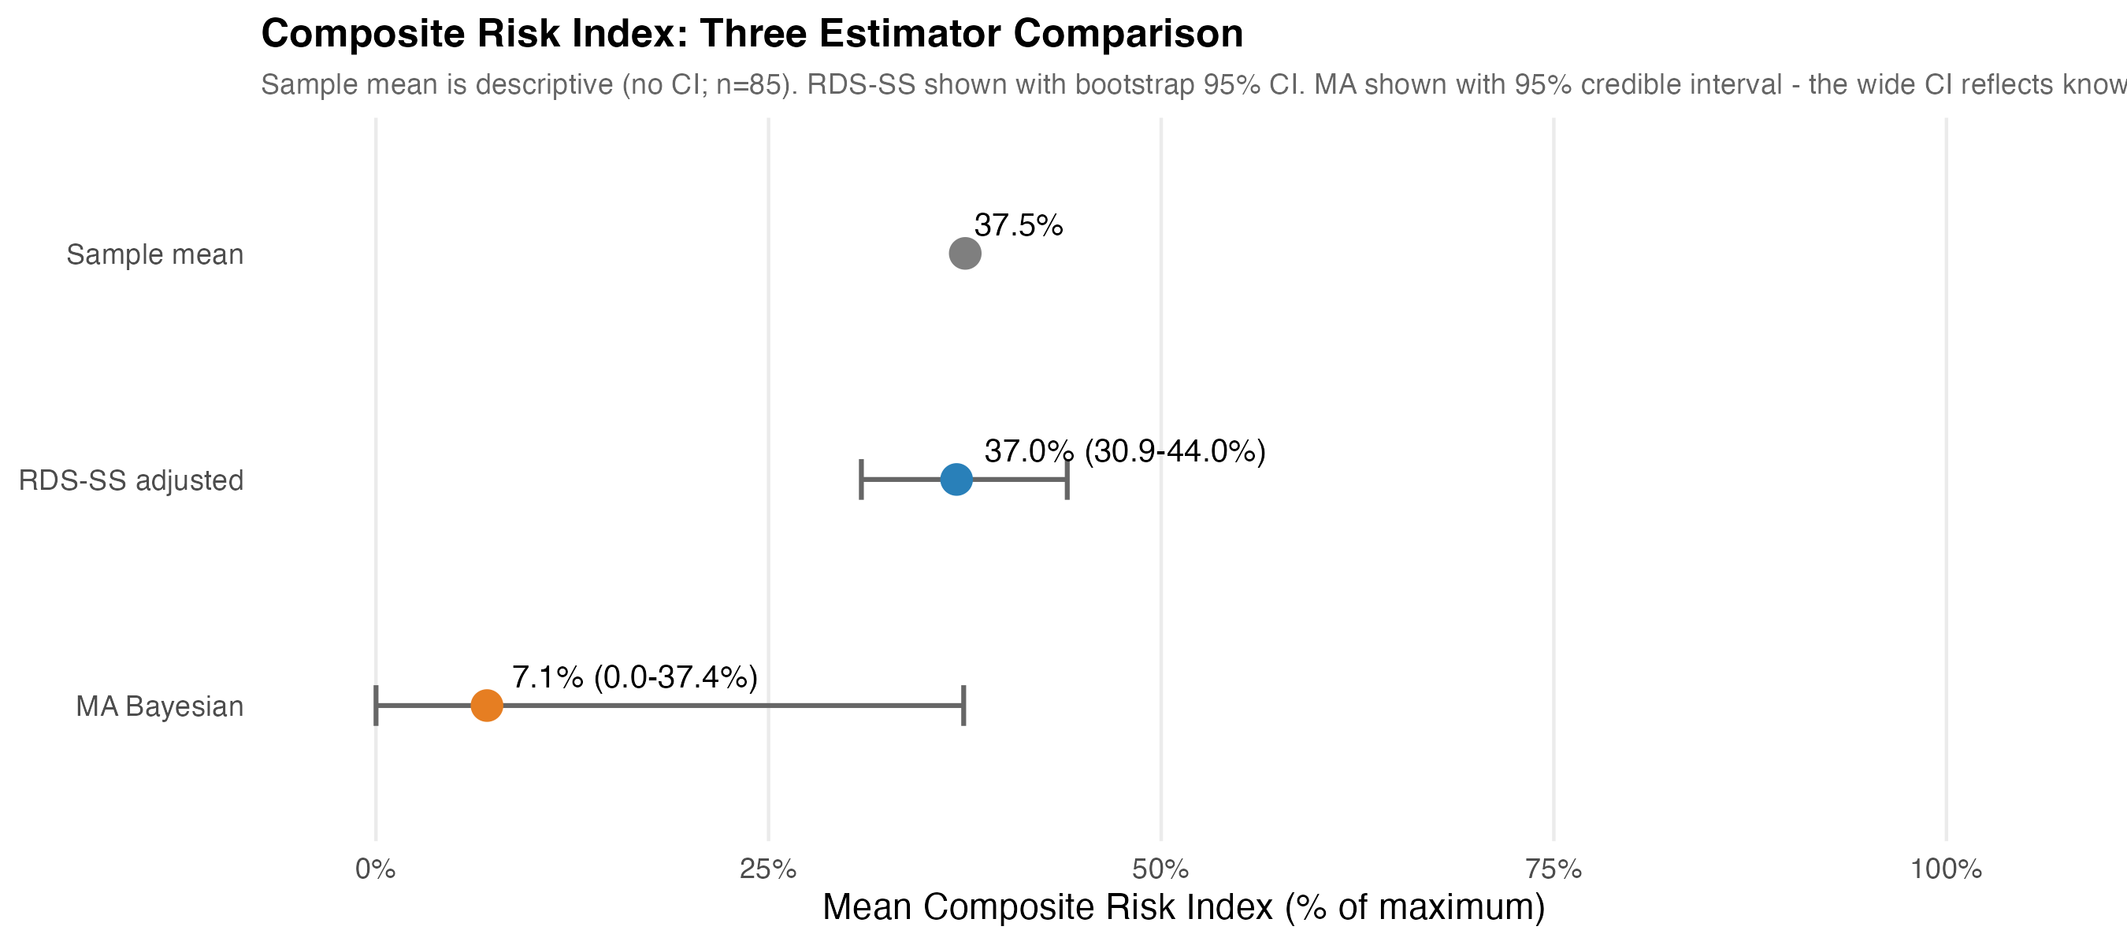
Figure 2. Composite Risk Index: Comparison of Three Estimators. Mean composite risk index across the observed RDS sample (descriptive; n=85), the RDS-SS adjusted estimator (Gile's Successive Sampling with bootstrap 95% CI), and the Bayesian Model-Assisted (MA) estimator (with 95% credible interval). The wide MA credible interval reflects known limitations of model-assisted inference for continuous outcomes; the RDS-SS estimate is the more reliable population-adjusted figure. Source: Authors' own work.

